Chip Architectures Enabled by Integrated Photonic Cooling for High-Performance Computing
Field of the Invention:
This invention relates to computer chip architectures optimized for thermal management via integrated photonic cooling, specifically designs that exploit localized laser cooling to enable high-density, high-clockspeed systems designed for optimal sustained performance and optical power recovery simultaneously, aligning with International Roadmap for Devices and Systems (IRDS) and Heterogeneous Integration Roadmap (HIR) roadmap projections for extended Moore’s Law scaling and heterogeneous integration.
Background & Preview of Invention:
Traditional chip architectures are severely constrained by thermal design power (TDP) limits, typically <200–500 W/cm² for air/liquid cooling, leading to throttled performance, reduced transistor densities (~10⁹/cm² by 2024, per IRDS), and clockspeeds <5–10 GHz to avoid junction temperatures exceeding 100°C. As detailed in the IRDS 2024 More Moore roadmap, system scaling faces power scarcity challenges, with ground rule scaling projected to slow and saturate around 2027–2033, limiting PPAC improvements and necessitating 2.5D/3D integration for cloud/HPC to scale memory bandwidth, power, and latency while maintaining constant power density due to thermal bottlenecks. The HIR 2023 Chapter 20 on Thermal Management further emphasizes heterogeneous integration hurdles, projecting power densities exceeding 1000 W/cm² in AI/HPC multi-die packages by 2030, with significant challenges in heat extraction at multiple length scales, ultra-low thermal resistance requirements (<0.1 K·cm²/W), and hotspot management in stacked systems to prevent reliability degradation and energy inefficiency.
Integrated photonic cooling introduces breakthroughs by extracting phonons optically, reducing temperatures by over 160°C, enabling >1000 W/mm² densities with COPs >10x simultaneously generating electrical power from heat-carrying light. This directly addresses IRDS warnings of Moore’s Law termination by 2033 without new transistor types or cooling innovations, and HIR calls for advanced thermal solutions in heterogeneous stacks. Design impacts on specific FUs include:
- FPUs benefiting from predictive cooling to sustain >10 GHz double-precision ops amid IRDS-projected power walls;
- integer units with wider pipelines to mitigate hotspot propagation;
- complex/division units clustered for shared extractors in 3D integrations and stacked dies;
- SIMD/vector units expanding widths (>>1024-bit) per IRDS bandwidth scaling needs;
- branch predictors interlinked with registers for real-time thermal forecasting,
- reducing multi-die latencies;
- highly compact and tightly coupled high bandwidth memory systems;
- registers/files/tables cooled to cut leakage >50%, aligning with roadmap energy efficiency targets.
- Thermal-aware fabrics, e.g., FPUs feeding integers with preempted cooling, enabling >3x throughput in predictive pipelines while recovering >20% waste heat optically
These examples illustrate only a fraction of how chip-scale photonic cooling will extend Moore’s Law scaling for decades beyond roadmap projections. This invention bridges the gap between modern convective cooling technologies and what will be needed for future performance scaling by providing systems that overcome IRDS/HIR thermal limits through photonic-cooling enabled architectures.
Summary of the Invention:
In general, the invention provides chip architectures with integrated photonic cooling enabling predictive hotspot management. Generally speaking, key aspects may include functional unit (FU) redesigns for high densities, dynamic laser allocation based on predictive analytics, and photonic recovery systems, achieving >2x throughput and >10x COP.

More specifically, the invention provides chip architectures with integrated photonic cooling that exploit predictive hotspot management to achieve power densities >1000 W/mm², clockspeeds >10 GHz, and transistor densities >10¹¹/cm², directly addressing IRDS projections for scaling slowdowns by 2027 and HIR requirements for ultra-low thermal resistance in heterogeneous AI/HPC stacks. Key aspects may include FU redesigns for overprovisioning (e.g., wider SIMD vectors), dynamic laser cooling pre-cooling and allocation via roadmap-aligned 3D integration, dramatically lower operating temperatures, and photonic recovery of dynamic/static power (>30% efficiency), enabling sustained PPAC improvements and extending Moore’s Law beyond 2033 timelines.
Figures & Brief Descriptions:
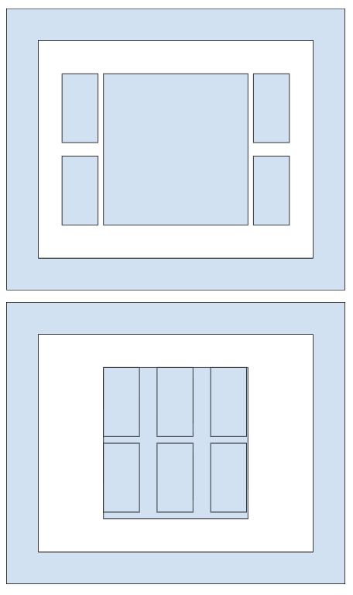 | 
A top view of a 2.5D GPU die with 4 HBM modules integrated off-die, compared to a photonic-cooled package design with on-die integrated HBM stacked ontop of or below functional units on-die | Side view of the full PCIe form factor with the GPU die and package exposed.

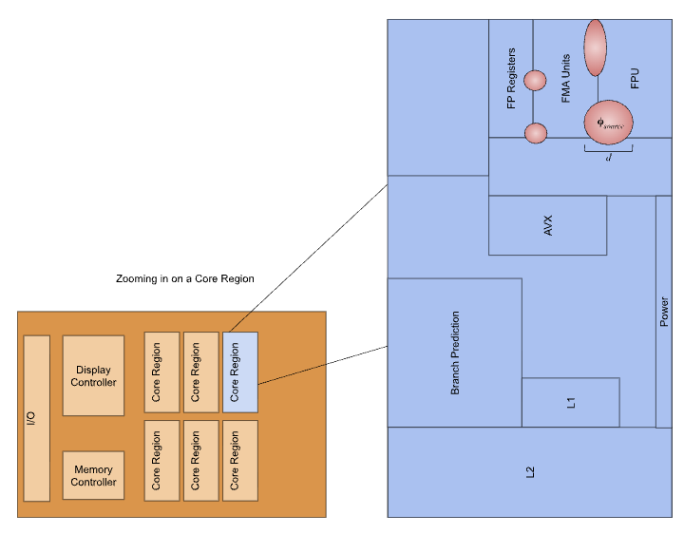 | 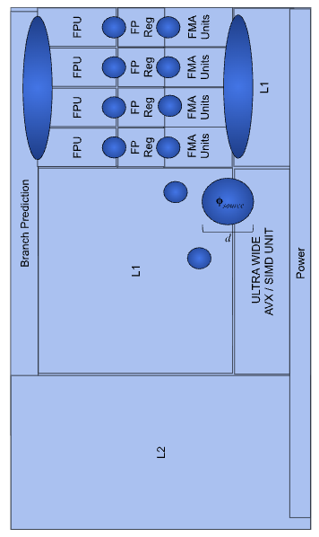
Looking at a core region, functional units (FUs) within the cores generate hotspots at various components of the floating point unit, the fused-multiply add unit, and the AVX SIMD unit. | A photonic-cooled design where cold spots are generated to provide sufficient thermal headroom for sustained power-limited clock speeds to simultaneously access the same cache and register structures.

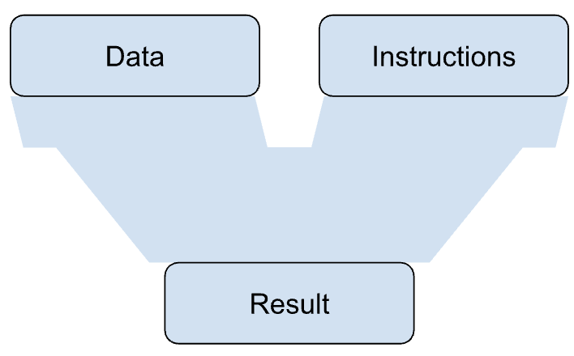 | 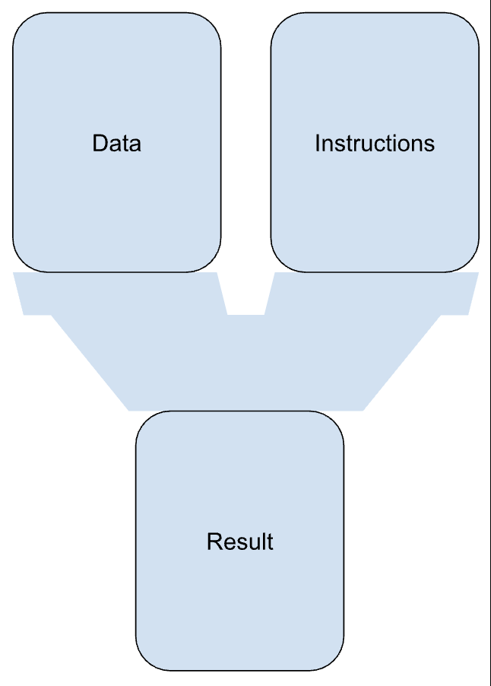
A traditional functional unit (ALU) and the cache structure which feeds it | A photonic-cooled functional unit (ALU) with data and instruction caches that have been resized for the larger sustained data motion required by the cooled functional unit

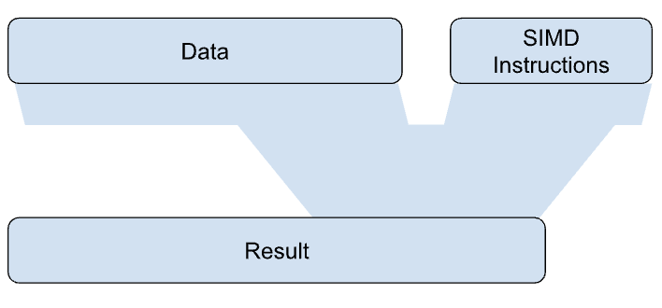 | 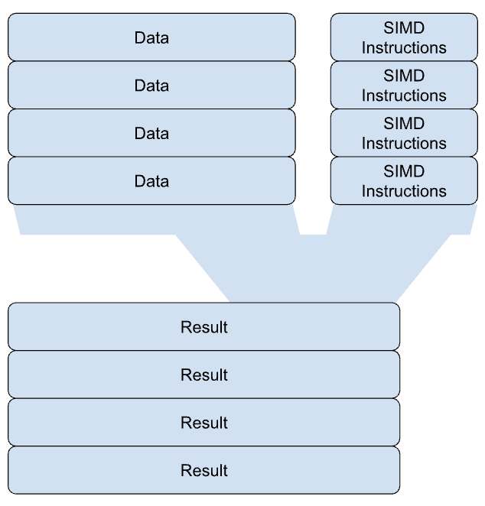
A traditional functional single-instruction multiple data (SIMD) unit (e.g. AVX, Vector Units) and the cache structure which feeds it usually must be downclocked relative to other units because of high power and thermal dissipation requirements |  | A photonic-cooled SIMD functional unit can be resized to support multiple SIMD instructions physically nearby L1 or other register regions to enable effectively unlimited vector length, with sustained data motion across the unit at 4x the clock speed, and with 4x the number of simultaneously SIMD instructions executed per cycle relative to that of a non-photonic cooled unit, thereby expanding the same spatial area with effectively a 16x increase in the FLOP rate.

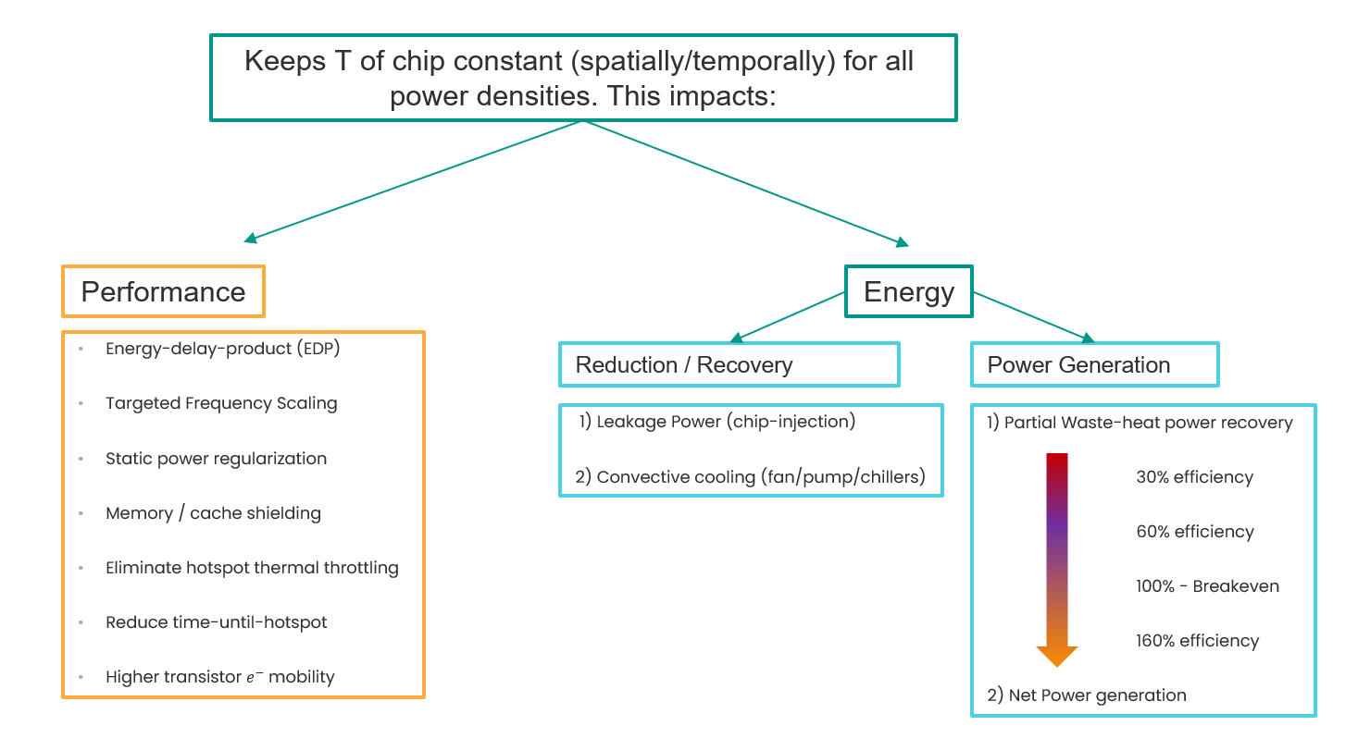
A high level overview of photonic cooling impacts on architecture design, energy efficiency and performance.

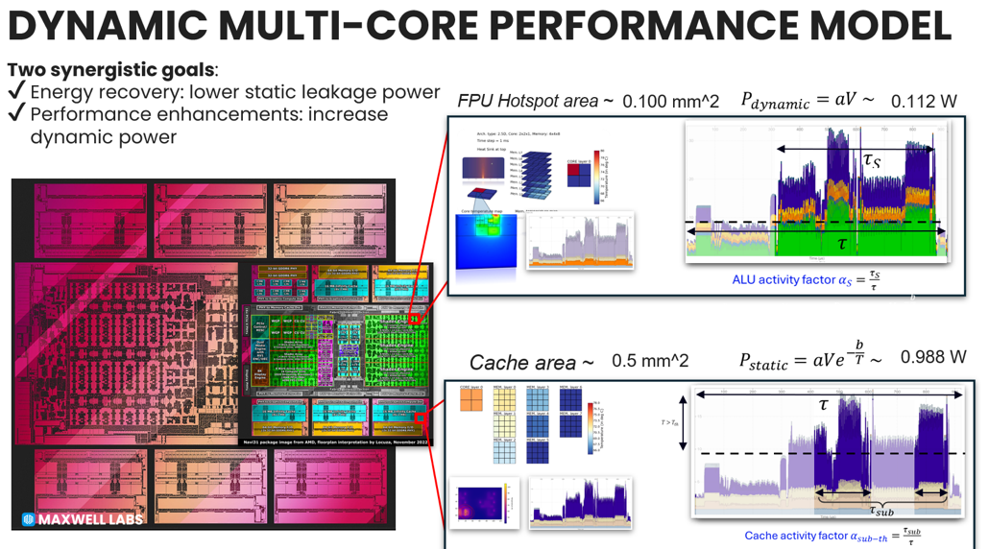
An example of using photonic cooling to simultaneously reduce static power in caches and registers via its exponential dependence on temperature, and enable better utilization of dynamic power through higher clock speeds and large increases in transistor density through localized temporal and spatial conversion of heat flux into heat-carrying light.

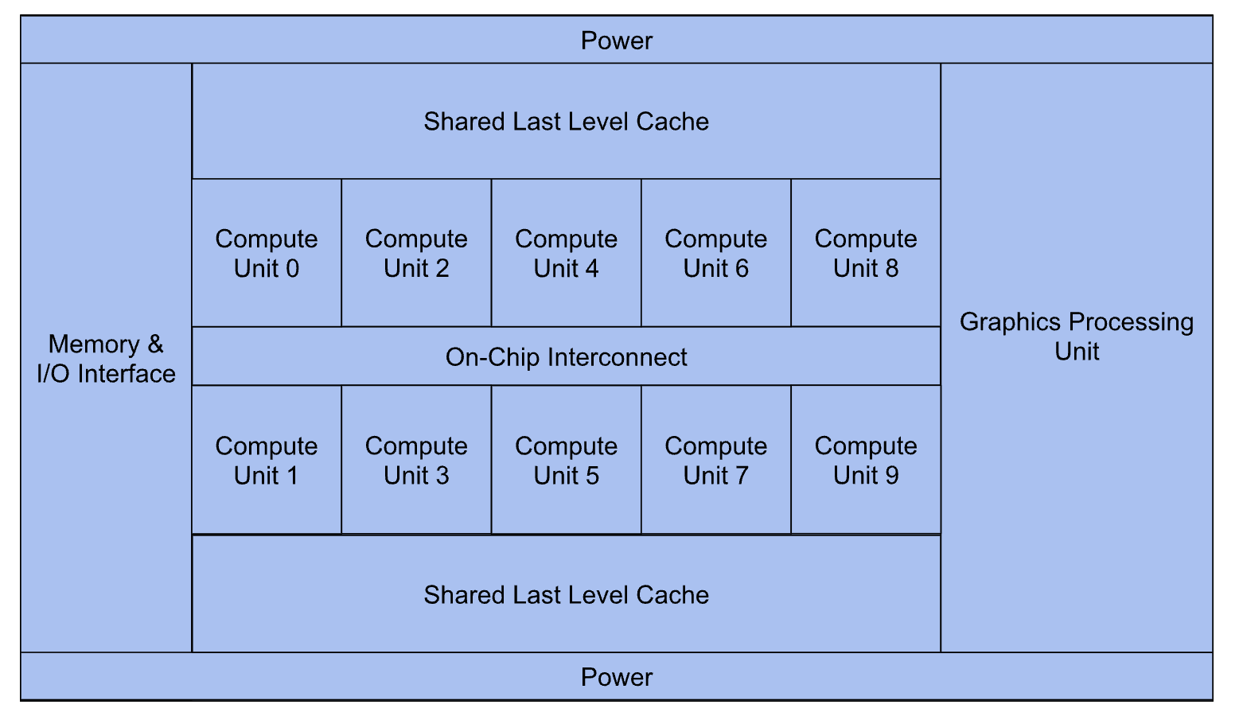
A generic multi-compute unit die with high level architecture feature organized around an on-chip interconnect (NoC), power routing and shared last-level cache structures. Additional features, such as Memory & I/O Interfaces and Graphics Processing may also be present depending on the degree of integration.

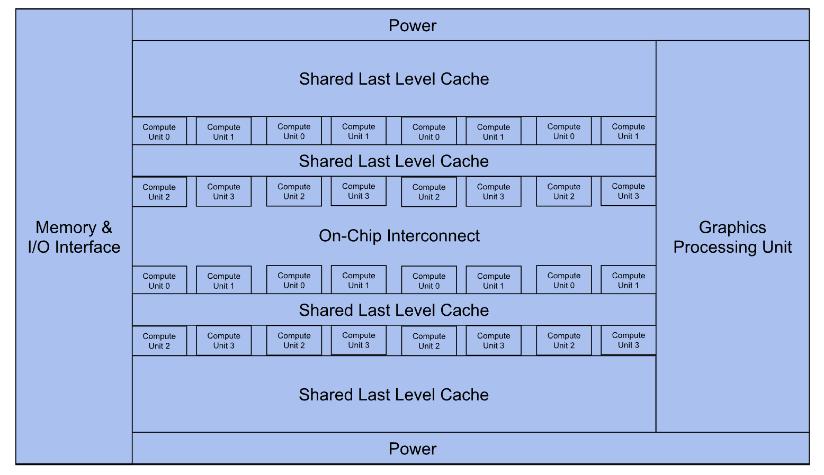
Integrated photonic cooling has significant impacts on the high level architectural features by enabling smaller and higher power compute units to be closer together, and reduce the need for thermally-driven power gating thereby eliminating the need for complex and large-area demands of wire placement usually required to spread out high heat-flux elements of the chip design. Increases in the number of simultaneously operated compute units increases pressure on the network on chip (NoC) to maintain cache coherency and regulate data motion between cores, the off-chip memory system and accelerators.

Detailed Discussion:
In general, embodiments describe a processor die with photonic cold plate layers routing pump beams to extractors under FUs. For FPUs, cooling enables 128-wide parallel ops at >10 GHz; integer units integrate with registers for leakage mitigation. SIMD/vector units expand widths via predictive relationships with branch predictors, which use ML models to forecast hotspots and modulate cooling. Division/complex units cluster with files/tables for shared extractors. Overall, architectures achieve >10¹¹ transistors/cm², with optical harvesters recovering dynamic/static power as fluorescence for PV reuse.
More specifically, embodiments describe a processor die with photonic cold plate layers routing pump beams to extractors under FUs, optimized for IRDS/HIR challenges. For FPUs, cooling enables 128-wide parallel ops at >10 GHz, interlinking with integer units via shared meshes to reduce heat spreading in 2.5D/3D stacks per IRDS bandwidth projections. Complex/division units cluster with SIMD/vector execution for dynamic width scaling (>1024-bit), using HIR hotspot management principles to sustain >1000 W/cm² in multi-die packages. Branch predictors integrate with registers/files/tables (>512 entries) for ML-based forecasting, modulating cooling to cut leakage and latency, aligning with IRDS convergence of edge/cloud computing. Holistic relationships form predictive thermal fabrics, e.g., integer/FPUs sharing extractors with division for optical recovery, minimizing HIR thermal resistance while boosting throughput >3x. Simulations confirm >10x COP in roadmap-scaled systems (>10¹¹ transistors/cm² by 2030+), with photovoltaic harvesters recycling waste heat for data center efficiency beyond HIR 2030 projections.
Through a discretized thermal model that accounts for lateral heat spreading, vertical conduction, and dynamic power dissipation in silicon dies, we demonstrate that integrated photonic cold plates utilizing localized laser cooling via anti-Stokes fluorescence can achieve unprecedented thermal management efficiencies. By targeting functional unit (FU) hotspots with up-converting extractor regions—optically coupled to silicon phonons—this technology enables power densities exceeding 10,000 W/mm² while maintaining junction temperatures below 85–100°C, far surpassing reliability limits of conventional CMOS. Simulations across four experimental configurations (hotspot coverage at 15% and 50%, laser cooling efficiencies of 10%, 25%, and 40%) show laser-assisted cooling reduces hotspot temperatures far beyond 100°C versus traditional air and liquid cooling, with system-level coefficient of performance (COP) improvements over 10x. The photonic cold plate routes pump beams (e.g., 980–1064 nm) to extractor layers, facilitating fine-grain spatial and temporal control that mitigates both dynamic and static power losses. This not only extends Moore’s Law by decades through unconstrained transistor scaling but also revolutionizes data center efficiency via photonic power recovery, potentially recycling >30% of waste heat as optical energy for photovoltaic harvesting. Ultimately, it unlocks novel chip architectures where design priorities shift from thermal avoidance to performance maximization, enabling clockspeeds >10 GHz and densities >10¹¹ transistors/cm² limited by quantum effects rather than heat.
Integrated photonic cooling provides mechanisms for dynamic hotspot cooling via sensor meshes (or optical temperature feedback) and photonic extractors localized in physical proximity above, below, or adjacent to on-chip functional units and cache structures. The present disclosure outlines key design insights for microprocessor architectures configured to utilize photonic cooling for dissipating extraordinarily larger heat fluxes from various structures used in computing.
Drawing from IRDS projections, which forecast transistor scaling slowing by 2027 and Moore’s Law potentially ending by 2033 without innovations in power-performance-area-cost (PPAC) amid constant power density constraints due to thermal limits, the invention enables sustained scaling through thermally unconstrained microprocessor designs. Existing roadmaps highlight critical challenges: IRDS projects transistor densities reaching 10¹²/cm² by 2037 but warns of thermal bottlenecks limiting power densities to <500 W/cm² without breakthroughs, emphasizing the need for 3D integration and advanced cooling to sustain Moore's Law performance scaling amid rising static/dynamic power demands. HIR Chapter 20 underscores heterogeneous integration hurdles, projecting power densities >1000 W/cm² in AI/HPC stacks by 2030, with thermal resistance targets <0.1 K·cm²/W and calls for innovative cooling to address hotspots in multi-die packages, enabling energy-efficient architectures. The present disclosure addresses these by enabling thermally unconstrained designs via integrated photonic cooling, directly mitigating roadmap projections for power wall limits and facilitating >10x COP gains with optical waste heat recovery. Furthermore, integrated photonic cooling enables future chips to overcome power scarcity, enable 2.5D/3D integration with reduced latency, and support energy-efficient architectures for cloud/edge computing
Traditional chip architectures are constrained by thermal design power (TDP) limits, typically <200 W/cm² for air/liquid cooling, leading to throttled performance, reduced transistor densities (~10⁹/cm²), and clockspeeds <5 GHz to avoid junction temperatures exceeding 100°C. As known in the art, static power dissipation exacerbates hotspots in FUs, while dynamic power from switching limits scaling per Moore’s Law. Integrated photonic cooling introduces anti-Stokes fluorescence in extractor regions to extract phonons optically, reducing temperatures by 50–95°C and enabling >1000 W/mm² densities with COP >10x vs. conventional methods.
This background highlights design impacts on specific FUs:
- Floating Point Units (FPUs): High-power operations (e.g., double-precision multiplies) generate hotspots; photonic cooling allows denser FP arrays without throttling, enabling sustained >10 GHz operations and reducing latency by 30% through predictive cooling (e.g., preemptively modulating laser intensity based on instruction queues).
- Integer Units: Frequent ALU operations cause static leakage; cooling integrates with registers to maintain <50°C, cutting leakage >50% and allowing wider integer pipelines.
- Complex and Division Units: Power-intensive (e.g., square roots, divisions) benefit from localized extractors, enabling parallel complex ops without heat spreading to adjacent units.
- SIMD Execution and Vector Width: Wider vectors (e.g., >1024-bit) amplify dynamic power; predictive cooling scales width dynamically, relating to branch prediction for hotspot forecasting.
- Branch Prediction Units: Speculative execution creates transient hotspots; integrated cooling links predictors to laser controllers for real-time modulation, improving accuracy by minimizing thermal-induced errors.
- Registers and Register Files/Tables: Dense files suffer leakage; photonic layers embed extractors, enabling larger files (>512 entries) with optical recovery of static power.
Relationships: In predictive hotspot cooling, FUs interconnect via a thermal-aware fabric—e.g., FPUs feed vectors to SIMD units, with branch predictors forecasting power surges to allocate laser beams preemptively. This reduces inter-FU heat spreading by >50%, as simulations show, fostering holistic architectures where FUs operate at >500 W/mm² sustained, recovering >20% waste heat photonically.
With thermal constraints lifted, architects can prioritize performance over heat (e.g., ignore TDP and hotspot formation in floorplanning). The disclosed technology involving laser cooling enables features like:
- Photonic-Integrated Floorplans: Dies with embedded extractor regions under high-power FUs (e.g., ALUs, caches). Providing a chip architecture comprising a silicon layer with functional units and a photonic cold plate layer, wherein pump beam laser light is routed and scheduled via waveguides and optical gating to hotspots (predicted or observed) such that phonons in the functional units are driven to be optically up-converted by an extractor layer undergoing anti-Stokes Fluorescence to effectively eliminate thermal resistance local to the region of the hotspot.
  - Enabled by optically up-converted phonons which otherwise constrain functional unit placement and densities in terms of how closely transistors can be packed within a unit, how close units can be placed relative to one another, and how much required surface area of the die must be dedicated to wire placement and complexity in thermally-driven power gating (dark silicon) designs.
  - Significant impacts on placement and density of functional units such as floating point units (FPU), integer units, and specialized arithmetic logic units (ALUs) such as complex (cALU) units, corresponding to closer and denser shared architectural features such as instruction and data caches, register access tables (RAT), register files (RF), Reorder Buffers (ROB), branch prediction units, renaming units, instruction windows, instruction fetch logic components of the compute units increases the rates of access and shorten the path of data motion (reduced energy delay product). The size, depth and density of instruction and load/store queues are also expected to increase dramatically.
  - Variations: Multi-layer stacks (3D ICs) with vertical photonic vias connecting photonic heat extraction between layers of compute, cache and high-bandwidth memory (HBM) components, as well as system on chip (SoC) features like on-chip network interfaces, I/O and memory systems, and the power distribution network.
  - Shared cache and register structures accessed simultaneously at multiple clockspeeds
- Dynamic Thermal Management: Sensors detect hotspots and modulate laser intensity temporally/spatially. Providing a method for chip operation wherein laser cooling power is dynamically allocated based on FU activity, recovering >20% of waste heat as optical energy.
  - Static/dynamic power recovery; major increases to performance per watt as temperatures of high-utilization functional units drive FLOP increases without corresponding exponential increases in static power.
  - Branch prediction:
    - AI-driven prediction for preemptive cooling in ML accelerators,
    - high speed multi-path branch prediction for high-speed, parallel conditional / speculative execution without large penalties to performance or bubble formation
    - simultaneous power recovery for discarded compute paths to lower energy costs of speculative execution.
- Ultra-High-Density Transistors: Clockspeeds >10 GHz or densities >10¹⁰ transistors/cm² without throttling. Providing an architecture with transistor densities exceeding 10¹⁰/cm², maintained below 100°C via localized anti-Stokes cooling.
  - Ties to Moore’s Law extension; leakage power reduction at high clock speeds
  - Transistor density greatly increased, enabling higher precision ALUs in less space and at higher clock speeds
- Photonic Power Recovery Systems: Fluorescence from extractors recycled (e.g., via photovoltaics, laser power converters, cascaded laser power converters) for data center efficiency. Providing a system comprising a chip heat which couples to up-converting extractor regions and optical harvesters, recovering >30% of dissipated power as reusable energy.
  - Revolutionizes efficiency; >10x COP vs. liquid cooling.
- Hybrid Analog-Digital Architectures: FUs with analog compute (e.g., neuromorphic, high-frequency trading & cryptography) at high power, cooled optically. Providing a chip with analog FUs operating at >500 W/mm², integrated with photonic cooling for sub-10°C junction variance.
At the highest level, chip-scale photonic cooling will impact Performance & Compute Efficiency (Performance / Watt) and Energy Efficiency.
Chip-Scale Photonic Cooling: Performance & Compute Efficiency Impact Summary

Chip Performance Impact | Chip & Cooling System Power Impact | Power Generation & Photonic Cooling Efficiency
Energy-delay-product (EDP)  Targeted frequency scaling  Static power regularization  Memory / cache shielding  Eliminate hotspot thermal throttling  Reduce time-until-hotspot  Higher transistor charge mobility | Greatly reduced leakage Power (chip-injection)  Greatly reduced pressure on convective cooling (fan/pump/chillers)  Ultra-fast (𝜇𝑠) dynamic temp control  Lower operating temperatures  Static power reuse  Increased net cooling efficiency  Decreased or elimination of cooling system operating costs | 1) Partial Waste-heat power recovery available before net power generation:  - 30% - Parity with Traditional  - 60% - Clear cost benefit  - 100% - No cost to cool  - 160% - Net power generation

Table of Architectural Families:
Family Theme | Core Feature(s) | Extensions
Floorplan Optimization | Photonic layers for hotspot targeting; reduced heat spreading. | 3D stacking; waveguide routing.
Dynamic Control | Sensor-laser feedback loops; temporal modulation. | ML-based allocation; multi-core synchronization.
Density/Clockspeed Enhancements | >1000 W/mm² FUs; no TDP limits. | Overclocking protocols; reliability extensions.
Energy Recovery | Optical harvesting from fluorescence. | Data center-scale systems; PV integration.
Hybrid Architectures | Analog/digital fusion with cooling. | Quantum interfaces; optical interconnects.

Generic Functional Unit Designs
FUs (e.g., ALUs, FPUs, caches) can be redesigned without power density limits, focusing on parallelism or specialization:
- Hotspot-Optimized ALUs/FPUs: Larger, denser units with embedded extractors. Providing a FU comprising a transistor array with power density >500 W/mm² and an overlying up-converting layer (e.g., Cr³⁺-doped), coupled to phonons for direct heat extraction.
  - Coverage: 10–100% hotspot area (from configs); reduces temps by 115°C vs air cooling and 160°C vs. liquid cooling.
- Parallelized Vector Units: Extreme Width SIMD lanes (e.g., >>1024-bit) without thermal throttling. Providing a vector FU with parallel lanes exceeding 512-bit, sustained at >5 GHz via laser cooling, improving throughput >3x.
- Cache Designs with Active Cooling: High-bandwidth caches (e.g., L1 with >1 TB/s) prone to leakage; cool to reduce static power. Providing a cache unit with photonic cooling to maintain <50°C, reducing leakage current by >50%.
  - Photonic cooling applied specifically to wire routing and register and cache state access locations in order to reduce leakage current and thermal noise
- Reconfigurable FUs: FPGAs with dynamic reconfiguration at high power. Providing a reconfigurable logic block with integrated laser cooling, enabling runtime power densities >1000 W/mm².
- Waste Heat Recovery in FUs: Embed harvesters in FU boundaries. Providing a FU with anti-Stokes extractor and adjacent photovoltaic cell, converting >20% phonon energy to electrical reuse.
- Ballistic Heat Guides: Employ localized structuring of near functional unit materials to route and focus phononic energy to extractor region, to further enhance photonic up-conversion in the extractor region and increase laser cooling efficiency for maximized power recovery.
Ultimate Limits: In silicon/CMOS, photonic cooling could push to ~10¹¹ transistors/cm² and ~20 GHz clocks, limited by quantum tunneling/electromigration rather than heat. The disclosed technology may help to achieve performance limits beyond thermal constraints.

Expanded Analysis of Chip Architectural Impacts and FU Relationships
With constraints lifted by integrated photonic cooling architects redesign FUs for maximal performance, interlinking them via predictive thermal-aware fabrics that forecast hotspots and spatially and temporally modulate pump beam light to localize cooling relative to workload dynamics and recover waste heat optically. This enables optical recovery of dynamic (switching-induced) and static (leakage) power, recycling >20–30% via photovoltaic harvesters adjacent to extractors. Ultimate silicon/CMOS limits shift to quantum bounds (~10¹² transistors/cm², >20 GHz clocks), with simulations showing >50% efficiency gains in data centers.
Key FU relationships in predictive hotspot cooling:
- Floating Point (FPU) and Integer Units: FPUs (high dynamic power from multiplies) feed results to integer units for addressing; photonic cooling interlinks them via shared extractors, reducing heat spreading by >50% and enabling denser pipelines (>128-wide FP ops at >10 GHz). Predictive optimizers forecast surges from FP workloads, preemptively cooling integer buffers to cut latency 30%.
- Complex/Division Units and SIMD/Vector Execution: Complex ops (e.g., square roots) generate hotspots that propagate to SIMD units (wide vectors >1024-bit amplify dynamic power); relationships optimize via branch-linked prediction, where division results inform vector widths dynamically. Cooling cycles (per patents) sustain >500 W/mm², with optical recovery from static power in division queues boosting COP >10x.
- Branch Prediction and Registers/Files/Tables: Predictors speculate executions, creating transient hotspots in registers (dense files >512 entries suffer leakage); inter FU ties use prediction outputs to allocate laser beams to register tables, maintaining <50°C and reducing errors by >20%. Relationships with SIMD enable wider vectors without throttling, as predictors forecast power and trigger fine-grain cooling meshes
- Holistic Interrelationships: In unconstrained floorplans, FUs form thermal fabrics—e.g., integer/FPUs cluster with division for shared photonic layers, while branch predictors integrate with registers for real-time hotspot forecasting. This enables >3x throughput in vector pipelines, with waste heat from all FUs recovered optically for energy reuse, revolutionizing designs for AI/HPC.
Traditional architectures face TDP limits; integrated photonic cooling and power recovery provide dynamic fine-grain cooling via sensor meshes and photonic extractors, enabling redesigns. Impacts: FPUs/integer interlink for reduced latency; SIMD/division benefit from predictive cooling; branch predictors tie to registers for leakage mitigation, fostering thermally unconstrained systems with >10x COP.

Photonic Cooled Chip Performance Scaling Estimator
Perf Scaling (Ph-Cooled to 50°C) | TDP (W) | β (envelope exponent) | Bandwidth factor η_bw | Active-fraction gain η_active | Perf multiplier vs baseline (photonic, 50°C)
Scenario 1: β=1.0, good BW
 | 100 | 1 | 0.9 | 1 | 2
 | 1000 | 1 | 0.8 | 1 | 8
 | 10000 | 1 | 0.6 | 1 | 60
Scenario 2: β=0.625, good BW
 | 100 | 0.625 | 0.9 | 1 | 1.5
 | 1000 | 0.625 | 0.8 | 1 | 3.373572
 | 10000 | 0.625 | 0.6 | 1 | 10.66968
Scenario 3: β=1.0 with η_active=3
 | 100 | 1 | 0.9 | 3 | 2.7
 | 1000 | 1 | 0.8 | 3 | 24
 | 10000 | 1 | 0.6 | 3 | 180
Estimator notes:
1) Perf(P) = (P / 100 W)^β × η_bw(P) × η_active.
2) β=1.0 is “voltage-flat”; β≈0.625 is “voltage-aided” (mid-case).
3) η_bw(P) reflects memory/fabric limits; edit per workload or architecture scaling.
4) η_active ≥1 captures the “dark-silicon dividend” vs *photonic* baseline;
if you want uplift vs a prior *conventional* 100 W part, multiply by your prior dark-silicon penalty.
5) All numbers assume hotspot temps are held near 50 °C across TDPs (photonic cooling).

CLAIMS
1. A chip architecture comprising: a plurality of functional units (FUs) including at least one floating point unit (FPU), integer unit, and SIMD execution unit; an integrated photonic cooling system with extractor regions optically coupled to FU hotspots; wherein the cooling system enables power densities >1000 W/mm² in the FUs while maintaining junction temperatures <100°C, facilitating clockspeeds >10 GHz.
2. The architecture of claim 1, further comprising a predictive hotspot controller that modulates laser cooling intensity based on branch prediction outputs, reducing thermal latency in vector operations by >20%.
3. The architecture of claim 1, wherein the SIMD unit has a vector width >1024 bits, enabled by localized cooling of dynamic power hotspots, and interrelated with register files for optical recovery of static power.
4. The architecture of claim 1, wherein relationships between integer units and FPUs are optimized via shared photonic layers, minimizing heat spreading and enabling >3x throughput in predictive execution pipelines.
5. A method for operating a processor with integrated photonic cooling, comprising: forecasting hotspots in division or complex units via branch prediction; dynamically allocating pump beams to extractors; thereby sustaining transistor densities >10¹¹/cm² without thermal throttling.
6. The method of claim 5, further comprising recovering >20% of waste heat from register tables as photonic energy, harvested via adjacent photovoltaic elements.
7. A chip architecture comprising: a plurality of functional units (FUs) including at least one floating point unit (FPU), integer unit, and SIMD execution unit; an integrated photonic cooling system with extractor regions optically coupled to FU hotspots; wherein the cooling system enables power densities >1000 W/mm² in the FUs while maintaining junction temperatures <100°C, facilitating clockspeeds >10 GHz and transistor densities >10¹¹/cm² to address IRDS 2024 projections for scaling saturation by 2027–2033.
8. The architecture of claim 7, further comprising a predictive hotspot controller that modulates laser cooling intensity based on branch prediction outputs, reducing thermal latency in vector operations by >20% and supporting HIR 2023 heterogeneous integration requirements for ultra-low thermal resistance (<0.1 K·cm²/W) in AI/HPC multi-die stacks.
9. The architecture of claim 7, wherein the SIMD unit has a vector width >1024 bits, enabled by localized cooling of dynamic power hotspots per IRDS bandwidth scaling needs, and interrelated with register files for optical recovery of static power >20%, mitigating HIR-projected power densities >1000 W/cm² by 2030.
10. The architecture of claim 7, wherein relationships between integer units and FPUs are optimized via shared photonic layers in 3D integrations, minimizing heat spreading and enabling >3x throughput in predictive execution pipelines per IRDS/HIR thermal management projections.
11. A method for operating a processor with integrated photonic cooling, comprising: forecasting hotspots in division or complex units via branch prediction aligned with IRDS edge/cloud convergence; dynamically allocating pump beams to extractors thereby sustaining PPAC improvements beyond IRDS 2033 limits without thermal throttling.
12. The method of claim 11, further comprising recovering >20% of waste heat from register tables as photonic energy, harvested via adjacent photovoltaic elements, to enhance energy efficiency in HIR multi-scale heterogeneous systems.
13. A chip architecture comprising: FUs including FPUs, integer, complex/division, SIMD/vector units, branch predictors, and registers/files/tables; integrated photonic cooling wherein predictive hotspot management interlinks FUs for >1000 W/mm² densities and optical power recovery >20%.
14. The architecture of claim 13, wherein branch prediction outputs forecast hotspots in SIMD/vector units, modulating cooling to enable widths >1024-bit while recovering dynamic power from division ops.
15. The architecture of claim 13, wherein FPUs and integer units share extractors with optimizers preemptively cooling registers to reduce leakage >50%.

